**Individual Project Report:**

**Flower Pod**

**Taylor Chevalier**

**ME 1670 – Section A**

**Summer 2021**

**Project Description**

For my Individual Project, I chose to create an artistic representation of an idea I’ve had regarding sustainable living on celestial bodies other than Earth; this Flower Pod is, essentially, a significantly smaller and more artistic version of a biodome, a structure meant to house and cultivate flora for the purpose of oxygen and food production on other planets. Of course, such an architectural feat would be significantly more complicated to produce in SolidWorks and would have taken much longer to model, so this smaller version proved more optimal. I also chose this design due to its more complex nature over my original chosen design of interlocking base and treble clefs; compared to my original first choice, the Flower Pod has more features and uses more techniques originally taught in the class, whereas the Clef Keychain would have consisted of a simple extrusion, a few revolve operations, and two fasteners. Overall, the Flower Pod allowed me to fully practice many of the operations taught throughout the course and helped develop a better sense of intuition regarding how to use CAD software to present ideas.

The basic design of the flower pod consists of three interlocking parts: a decorative base, a dome, and a flower. The dome was designed to completely house the flower, “protecting it from harm,” in a metaphorical sense. It also has a keyring on top to hang from a bag if desired. The base consists of a hollowed octagonal prism with a post in the center to hold the lower in place. The flower itself is a simple cylinder with another octagonal prism and eight staggered petals created using the Boundary Boss feature. The flower also contains a threaded Extrude Cut at the bottom, where it screws into the base

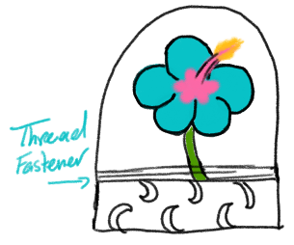

*Figure 1: Sketch of assembled Flower Pod*

Note that these preliminary sketches have several differences compared to the final product. Many of these differences came from understanding the use of SolidWorks as a medium of production; some of the features had to be altered in order to achieve the overall idea, such as decoration and practicality of fasteners (this will be further discussed in Design for Manufacturing Considerations).

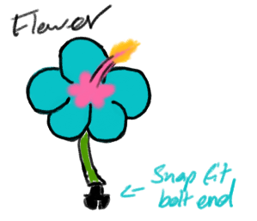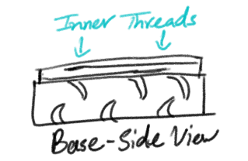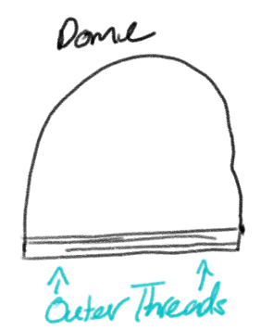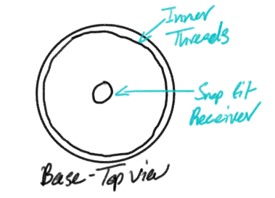

*Fig. 2: Sketches for individual parts*

**CAD Features**

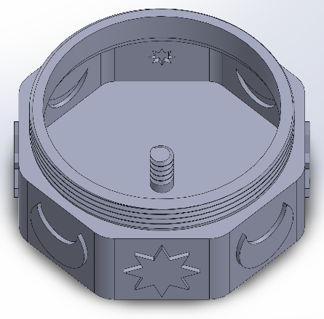**Base**

Extrusion

Extrusion and Thread

(Interlocking)

* Extrusion
* Fillet
* Mirror
* Shell

Shell

* Thread

Extrusion and Mirror

Fillet

**Dome**

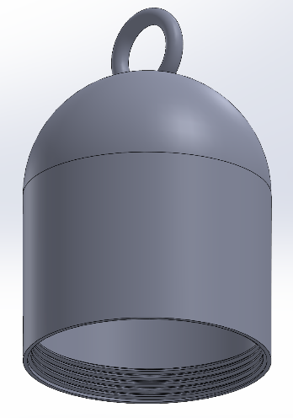

Revolve

Shell

Thread

(Interlocking)

* Revolve
* Shell
* Thread

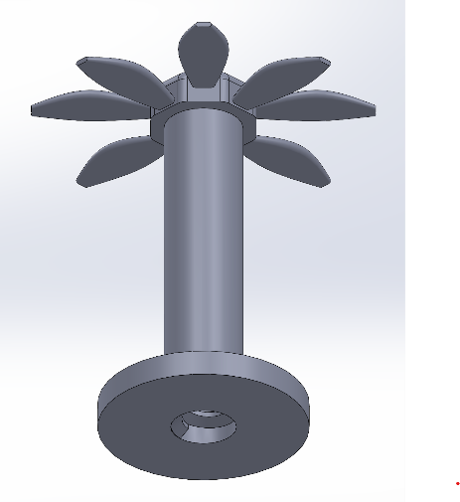

Extrusion

Boundary

Fillet

Extrude Cut and Thread

(Interlocking)

**Flower**

* Extrusion
* Fillet
* Boundary
* Extrude Cut
* Thread

**Interlocking Features**

The only interlocking features are between the dome and base and the flower and base. Both use a screw mechanism, with cut threads on the outer rim and post of the base, and extrude threads on the insides of the dome and flower.

**Design for Manufacturing Considerations**

There were very few difficulties in the manufacturing process of the Flower Pod thanks to tolerances and a set minimum thickness of 0.04in which prevented any potential for structural damage. The only manufacturing issue came from the flower, specifically the Extrude Cut and Thread at its base; for some reason, the Extrude Cut of the final product was not the correct dimension from the original model. This could be due to lack of tolerances or packed in powder from the manufacturing process itself.

The interlocking mechanisms I chose were screws. I wanted a fastener that would allow for the Flower Pod to be easily disassembled and reassembled; after all, I wanted to be able to open the pod to see the flower inside. I also wanted to create a sense of flexibility in the product, in that it doesn’t have to remain in the same state forever, thus leading to the choice of impermanent fasteners. As for tolerances, I used a tolerance of 0.5mm to ensure that the screw mechanism between the dome and base functioned properly. One of the major reasons why the flower did not screw properly into the base was due to a lack of tolerances; this was most likely due to negligence, unfortunately.

The most likely areas of concern for manufacturing were the keyring and especially the flower. These required a significant amount of calculation to ensure that they not only fit within the assembly, but also fit within the maximum amount of material of 4in­­­3 without breaching the 0.04in minimum thickness.

For the base, I chose to replace the circular base seen in the preliminary sketches with an octagonal base as seen in the final product. I felt that a flat surface was much easier to work with than a rounded one in order to create the moon and star decorations that would represent the setting of this metaphorical biodome (it would be located on a moon or another planet). To create the decorations, themselves, I sketched two moons and two stars on perpendicular faces to each other, then mirrored each one to achieve an alternating pattern around the base. I also made sure to shell the base so as to lower the amount of material used overall.

I used the same concept as the base to create the petals of the flower. The center of the flower is another octagonal prism, but with more fillets to achieve a more organic shape. After some research online along with trial and error, I learned how to use the Boundary boss feature after trying and failing to use the Loft and Sweep features. The Boundary feature allowed me to create an organic shape that could not be achieved any other way.

To trouble shoot, I used the assembly model. This allowed me to make sure that tolerances were made and that the overall design did not exceed the material limit.

**Challenges Faced in Manufacturing**

Unfortunately, the assembly proved only partially successful. The base and dome were able to screw together with enough force and patience. The flower, however, could not screw into the base at all. As stated earlier, the Extrude Cut did not turn out as deep as I had designed it to be. Pair this with the blatant lack of tolerances for the threads, and it resulted in an unusable product. In the future, I could simply sand away the threads and glue the flower in place, but this defeats the purpose of having impermanent fasteners.

In the effort of making the design process more efficient in future projects, it is apparent that I must be sure to draw out my ideas in much more detail before designing in CAD. By addressing concerns such as dimensions and interlocking mechanisms earlier on, I can prevent myself from having to decide such things in SolidWorks. And any changes that need to be made during troubleshooting in the assembly process should be documented, as well.

**Tolerance Analysis**

Quite a few of the dimensions of the final product were slightly larger or smaller than the original CAD design. Unsurprisingly, the Extrude Cut of the flower showed the greatest percent difference due to issues in design and manufacturing. The only change that I did not expect and cannot explain is the decrease in size of the domes thread thickness.

|  |  |  |  |
| --- | --- | --- | --- |
| Feature | Dimension in CAD | Actual Measurement | Percent Difference |
| Post diameter (located in center of base) | 0.25 in | 0.25 in | 0% |
| Flower Extrude Cut diameter | 0.30 in | 0.28 in | 6.67% |
| Flower Extrude Cut depth | 1.40 in | 0.3 in | 78.6% |
| Flower stem diameter | 0.40 | 0.3 in | 6.67% |
| Base thread thickness (thickness of overall extrusion) | 0.14 in | 0.2 in | 42.9% |
| Dome thread thickness (or thickness of Dome shell) | 0.5 in | 0.1 in | 80% |
| Dome loop thickness (diameter of ring) | 0.2 in | 0.2 in | 0% |
| Dome loop inner diameter | 0.70 in | 0.71 in | 1.4% |
| Dome loop outer diameter | 1.10 in | 1.12 in | 1.8% |

**Conclusions**

Over the course of this design process, I had to evaluate and reevaluate how I was going to achieve the final look, along with what features would be feasible and what would not. Much of this process occurred through extensive trial and error, some of which may have been avoided through more planning beforehand. Overall, I have learned that one must be very detail-oriented when producing CAD models to ensure an easy manufacturing process or a better understanding of ideas over all. I look forward to taking what I’ve learned and improving my skills in the future.